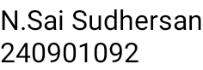WEEK 5

Q) Write a program that prints a simple chessboard.

Input format:

The first line contains the number of inputs T.

The lines after that contain a different values for size of the chessboard Output format:

Print a chessboard of dimensions size \* size. Print a Print W for white spaces and B for black spaces.

Input: 2

3

5

Output:

WBW BWB WBW WBWBW BWBWB WBWBW BWBWB WBWBW

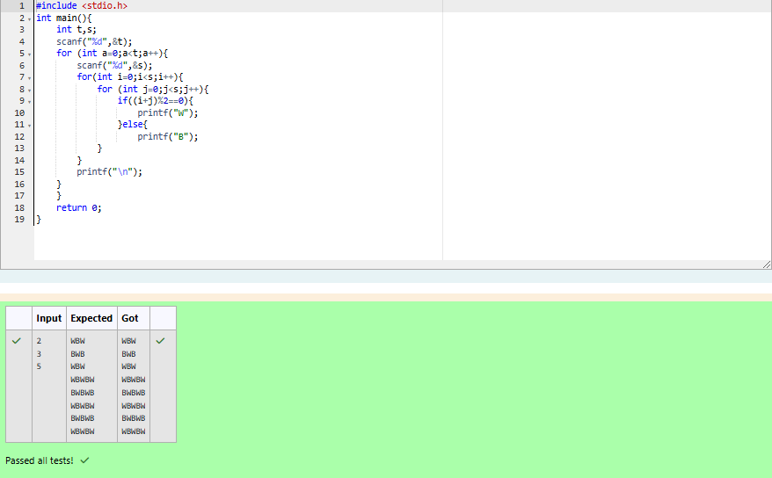

Q) Let’s print a chessboard!

Write a program that takes input:

The first line contains T, the number of test cases

Each test case contains an integer N and also the starting character of the chessboard Output Format

Print the chessboard as per the given examples Sample Input / Output

Input: 2

2 W

3 B

Output: WB

BW BWB WBW BWB

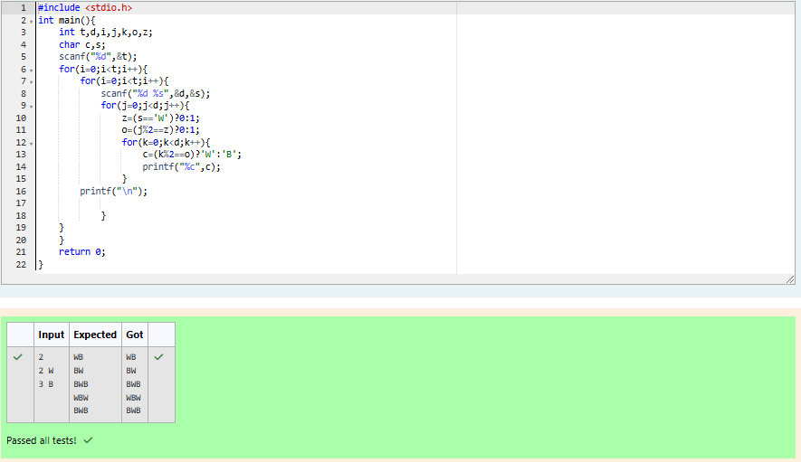

Q) Decode the logic and print the Pattern that corresponds to given input.

If N= 3

then pattern will be : 10203010011012

\*\*4050809

\*\*\*\*607

If N= 4, then pattern will be: 1020304017018019020

\*\*50607014015016

\*\*\*\*809012013

\*\*\*\*\*\*10011

Constraints

2 <= N <= 100

Input Format

First line contains T, the number of test cases Each test case contains a single integer N Output

First line print Case #i where i is the test case number In the subsequent line, print the pattern

Test Case 1

3

3

4

5

Output

Case #1

10203010011012

\*\*4050809

\*\*\*\*607

Case #2

1020304017018019020

\*\*50607014015016

\*\*\*\*809012013

\*\*\*\*\*\*10011

Case #3

102030405026027028029030

\*\*6070809022023024025

\*\*\*\*10011012019020021

\*\*\*\*\*\*13014017018

\*\*\*\*\*\*\*\*15016

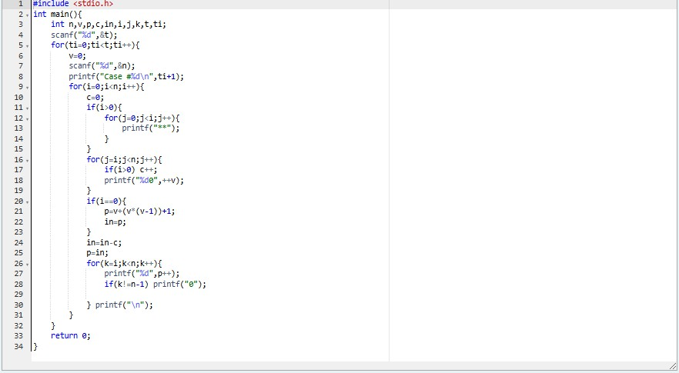

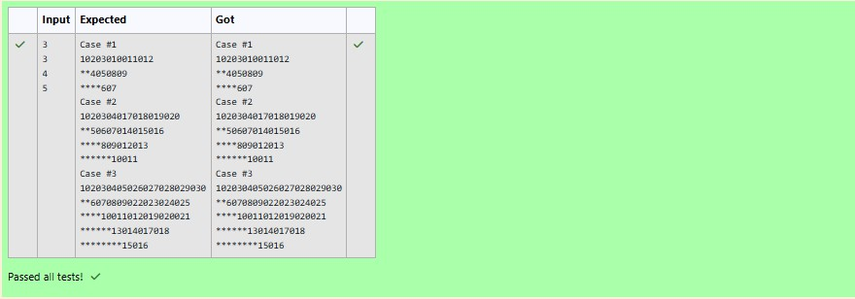

Q) The k-digit number N is an Armstrong number if and only if the k-th power of each digit sums to N.

Given a positive integer N, return true if and only if it is an Armstrong number. Example 1:

Input:

153

Output:

true Explanation:

153 is a 3-digit number, and 153 = 1^3 + 5^3 + 3^3. Example 2:

Input:

123

Output:

false Explanation:

123 is a 3-digit number, and 123 != 1^3 + 2^3 + 3^3 = 36.

Example 3: Input:

1634

Output:

true Note:

1 <= N <= 10^8

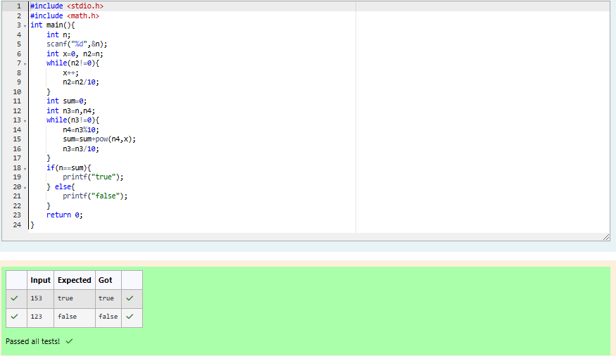

Q) Take a number, reverse it and add it to the original number until the obtained number is a palindrome. Constraints 1<=num<=99999999 Sample Input 1 32 Sample Output1 55

Sample Input 2 789 Sample Output 2 66066

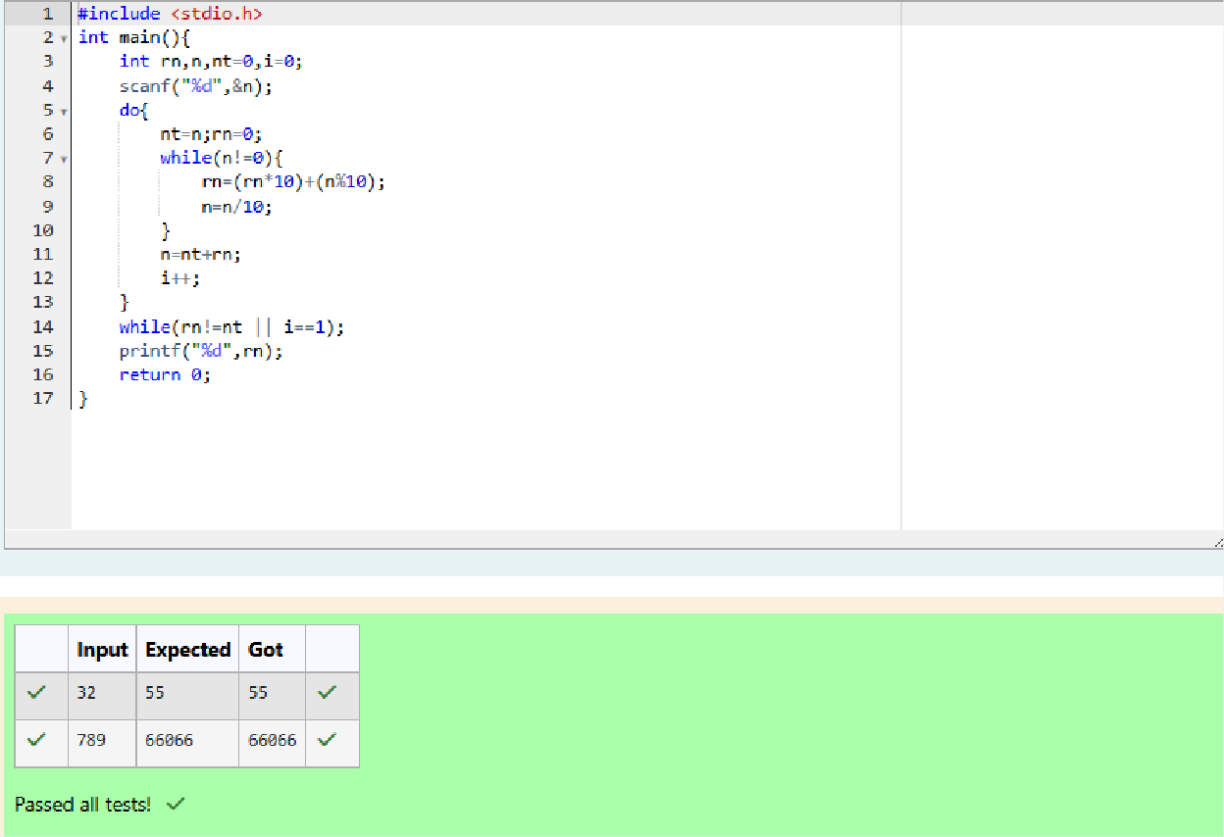

Q) A number is considered lucky if it contains either 3 or 4 or 3 and 4 both in it. Write a program to print the nth lucky number. Example, 1st lucky number is 3, and 2nd lucky number is 4 and 3rd lucky number is 33 and 4th lucky number is 34 and so on. Note that 13, 40 etc., are not lucky as they have other numbers in it.

The program should accept a number 'n' as input and display the nth lucky number as output.

Sample Input 1:

3

Sample Output 1:

33

Explanation:

Here the lucky numbers are 3, 4, 33, 34., and the 3rd lucky number is 33.

Sample Input 2:

34

Sample Output 2:

33344

